TASK 1

Three phase motor operated with full voltage magnetic starter controlled by stop & start push button station

Power Circuit

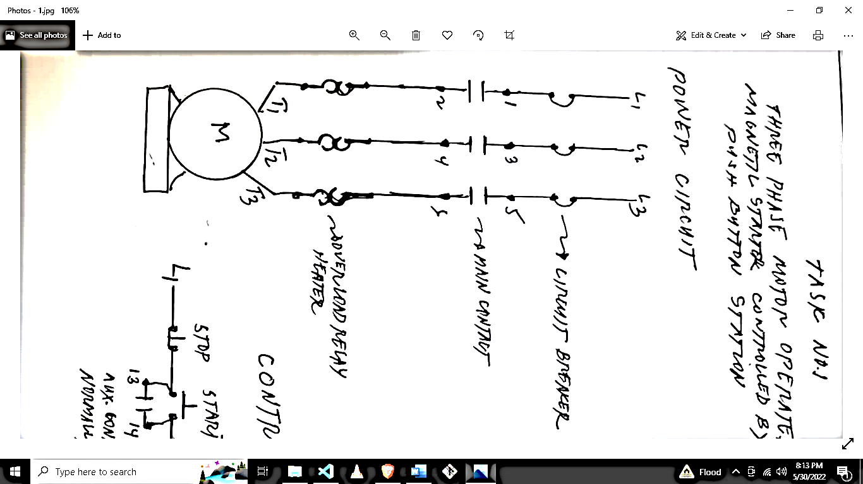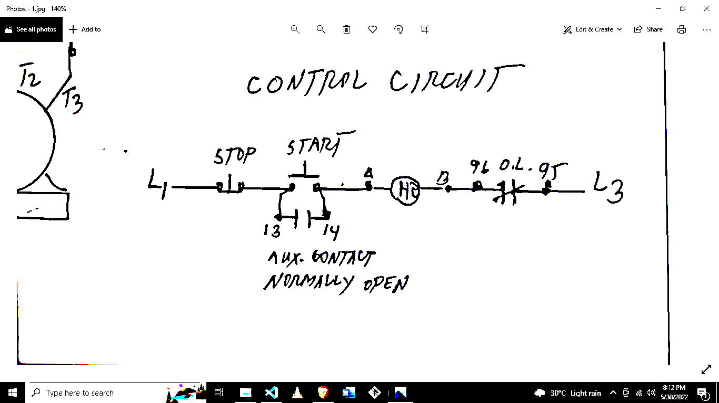

Checked By:

Rudy C. Docoy

Overload Relay Heater

Main Contact

Circuit Breaker

Auxiliary Contact Normal Open

MOTOR CONTROL

**Date :**May 31, 2022

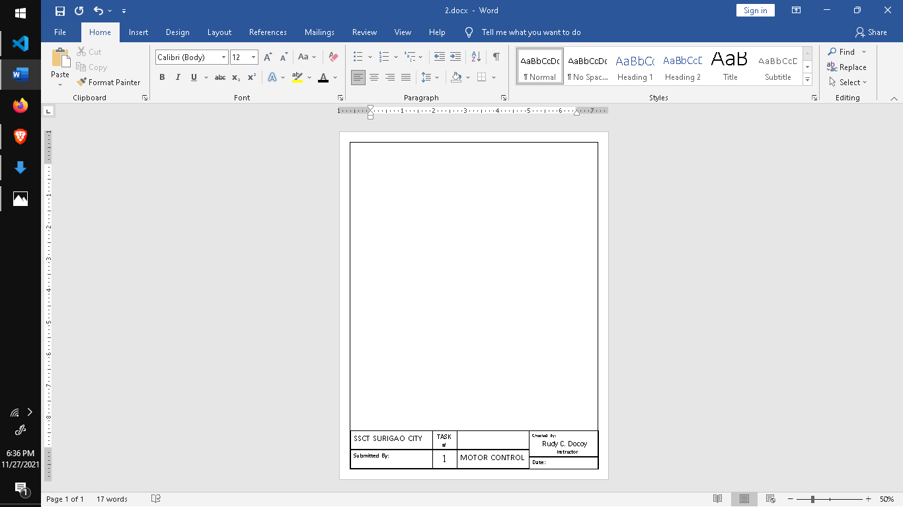



TASK #

1

SSCT SURIGAO CITY

Submitted By:

Control Circuit

Instructor



BEET 3C